MADHAV INSTITUTE OF TECHNOLOGY & SCIENCE

Deemed to be University
(Declared under Distinct Category by Ministry of Education, Govt. of India)
NAAC Accredited with A++ Grade


Project Report

on

Development of iControl (AMM Module)

Submitted By:
Aniket Arora (0901CA221013)

Industry Mentor:
Dr. Sankarlal Thillaiambalam (Director, iComply Life Science Solutions Private Limited)

Faculty Mentor:
Dr. R. S. Jadon (Professor)

MADHAV INSTITUTE OF TECHNOLOGY & SCIENCE

Deemed to be University
(Declared under Distinct Category by Ministry of Education, Govt. of India)
NAAC Accredited with A++ Grade

Project Report

on

Development of iControl (AMM Module)

A project report submitted in partial fulfilment of the requirement for the degree of

MASTER IN COMPUTER APPLICATION
in

COMPUTER SCIENCE AND ENGINEERING

Submitted By:
Aniket Arora (0901CA221013)

Industry Mentor:
Dr. Sankarlal Thillaiambalam (Director, iComply Life Science Solutions Private Limited)

Faculty Mentor:
Dr. R. S. Jadon (Professor)



Reference Number: ICOM/INT/IC-028 Dated: 21th April 2024

PROJECT COMPLETION CERTIFICATE
This is to certify that Mr. Aniket Arora has successfully completed his project with us at iComply Life Science Solutions Private Limited, under the designation of Software Developer in the Information Technology Department. His project commenced on 20th December 2023 and concluded on 16th April 2024, during which he exhibited commendable conduct and professionalism.
Throughout the project, Mr. Aniket Arora actively contributed to the development of the iControl (AMM Module), a dynamic web application aimed at enhancing user experience and functionality. His responsibilities encompassed frontend and backend development tasks, including designing user interfaces, writing clean and efficient code, and integrating various APIs.
His dedication, integrity, and collaborative spirit were evident throughout the project. He consistently maintained a positive attitude, communicated effectively with team members, and demonstrated excellent problem-solving skills. His professionalism and commitment to delivering high-quality work reflect his strong character and work ethic.

Based on the exemplary performance and clear potential exhibited throughout the project, we highly recommend Mr. Aniket Arora to continue pursuing opportunities for skill development and professional growth in the field of Software Development. With a solid foundation and a keen enthusiasm for learning, we believe he has a bright future ahead in this industry.


Selvasaroja
Director
iComply Life Science Solutions Private Limited

iComply Life Science Solutions Private Limited
Office Address: Office No 10, Third Floor, Akshaya HQ, Rajiv Gandhi IT expressway,
Kazhipattur, OMR, Chennai, Tamilnadu- 603103 www.icomplylifesciences.com

MADHAV INSTITUTE OF TECHNOLOGY & SCIENCE

Deemed to be University
(Declared under Distinct Category by Ministry of Education, Govt. of India)
NAAC Accredited with A++ Grade

CERTIFICATE

This is certified that Aniket Arora (0901CA221013) has submitted the project report titled Development of iControl (AMM Module) under the mentorship of Dr. Sankarlal Thillaiambalam (Director, iComply Life Science Solutions Private Limited), in partial fulfilment of the requirement for the award of degree of Master in Computer Application of Computer Science and Engineering from Madhav Institute of Technology and Science, Gwalior.

Dr. R. S. Jadon Dr. Manish Dixit
(Professor) (Professor and Head)
Computer Science and Engineering Computer Science and Engineering

MADHAV INSTITUTE OF TECHNOLOGY & SCIENCE

Deemed to be University
(Declared under Distinct Category by Ministry of Education, Govt. of India)
NAAC Accredited with A++ Grade

DECLARATION

I hereby declare that the work being presented in this project report, for the partial fulfilment of requirement for the award of the degree of Master in Computer Application in Computer Science and Engineering at Madhav Institute of Technology & Science, Gwalior is an authenticated and original record of my work under the mentorship of Dr. Sankarlal Thillaiambalam (Director, iComply Life Science Solutions).
I declare that I have not submitted the matter embodied in this report for the award of any degree or diploma anywhere else.

Aniket Arora 0901CA221013
2022-2024
Master in Computer Application Computer Science and Engineering

MADHAV INSTITUTE OF TECHNOLOGY & SCIENCE

Deemed to be University
(Declared under Distinct Category by Ministry of Education, Govt. of India)
NAAC Accredited with A++ Grade

ACKNOWLEDGEMENT

The full semester project has proved to be pivotal to my career. I am thankful to my institute, Madhav Institute of Technology and Science to allow me to continue my disciplinary project. I extend my gratitude to the Director of the institute, Dr. R. K. Pandit and Dean Academics, Dr. Manjaree Pandit for this.

I would sincerely like to thank my department, Department of Computer Science and Engineering, for allowing me to explore this project. I humbly thank Dr. Manish Dixit, Professor and Head, Department of Computer Science and Engineering, for his continued support during the course of this engagement, which eased the process and formalities involved.

I would like to extend my heartfelt appreciation to Dr. Sankarlal Thillaiambalam (Director, iComply Life Science Solutions Private Limited) for his exceptional mentorship, guidance, and assistance throughout the project. His valuable input and feedback during the course of the project have helped me enhance my knowledge and skills. His constant encouragement and support have been instrumental in the successful completion of this project.

I am sincerely thankful to my faculty coordinator. I am grateful to the guidance of Dr. R. S. Jadon, (Professor), Computer Science and Engineering, for his continued support and guidance throughout the project. I am also very thankful to the faculty and staff of the department.

Aniket Arora 0901CA221013
2022-2024
Master in Computer Application Computer Science and Engineering

ABSTRACT

The Audit Management Module (AMM) addresses the challenges faced by organizations in effectively managing audit processes in a digital environment. Recognizing the complexity and inaccessibility of current systems, particularly for non-technical users, AMM introduces a user-friendly web application with intuitive design and accessibility features.

AMM streamlines the audit process, offering simplified onboarding, comprehensive audit planning and scheduling, and efficient documentation and reporting capabilities. Built-in tools facilitate communication and collaboration among audit teams, ensuring seamless coordination and workflow management. Additionally, AMM enhances data security and integrity through robust encryption and access controls.

AMM also provides firms with real-time analytics and insights, which facilitate proactive risk management and educated decision-making. Adaptability to changing audit requirements and organizational growth is ensured by scalable architecture. Extensive training and support materials enable efficient platform use, enabling users to fully realize the platform's potential.

In summary, AMM serves as a transformative solution, bridging traditional audit practices with the digital age. By enhancing efficiency, security, and decision-making capabilities, it fosters a culture of compliance and accountability, ultimately contributing to organizational resilience and success.

सार
ऑडिट प्रबंधन मॉड्यूल (ए एम एम) डिडिटल वातावरण में ऑडिट प्रडियाओं को प्रभावी ढंग से प्रबंडधत करने में संगठनों के सामने आने वाली चुनौडतयों का समाधान करता है। वततमान प्रणाडलयों की िडटलता और दुगतमता को पहचानते हुए, डवशेष रूप से गैर-तकनीकी उपयोगकतातओं के डलए, एएमएम सहि डििाइन और पहुंच सुडवधाओं के साथ एक उपयोगकतात-अनुकूल वेब एप्लिकेशन पेश करता है।
एएमएम ऑडिट प्रडिया को सुव्यवप्लित करता है, सरलीकृत ऑनबोडििंग, व्यापक ऑडिट योिना और शेड्यूडलंग और कुशल दस्तावेजीकरण और ररपोडटिंग क्षमताओं की पेशकश करता है। अंतडनतडहत उपकरण ऑडिट टीमों के बीच संचार और सहयोग की सुडवधा प्रदान करते हैं, डिससे डनबातध समन्वय और वकत फ़्लो प्रबंधन सुडनडित होता है। इसके अडतररक्त, एएमएम मिबूत एप्लरिप्शन और एक्सेस डनयंत्रण के माध्यम से िेटा सुरक्षा और अखंिता को बढाता है।
एएमएम फमों को वास्तडवक समय डवश्लेषण और अंतर्दतडि भी प्रदान करता है, िो सडिय िोप्लखम प्रबंधन और डशडक्षत डनणतय लेने की सुडवधा प्रदान करता है। स्केलेबल आडकत टेक्चर द्वारा बदलती ऑडिट आवश्यकताओं और संगठनात्मक डवकास के डलए अनुकूलनशीलता सुडनडित की िाती है। व्यापक प्रडशक्षण और सहायता सामग्री
िेटफॉमत के कुशल उपयोग को सक्षम बनाती है, डिससे उपयोगकतात िेटफॉमत की क्षमता का पूरी तरह से एहसास कर पाते हैं।
संक्षेप में, एएमएम एक पररवततनकारी समाधान के रूप में कायत करता है, िो पारंपररक ऑडिट प्रथाओं को डिडिटल युग के साथ िोड़ता है। दक्षता, सुरक्षा और डनणतय लेने की क्षमताओं को बढाकर, यह अनुपालन और
िवाबदेही की संस्कृडत को बढावा देता है, अंततः संगठनात्मक लचीलेपन और सफलता में योगदान देता है।

LIST OF FIGURES
Figure Caption Page No.
FIGURE 1 LEVEL 0 DFD 9
FIGURE 2 LEVEL 1 DFD 10
Figure 3 Level 2 DFD (Process 1) 11
Figure 4 Level 2 DFD (Process 2) 12
Figure 5 Level 2 DFD (Process 3) 13
Figure 6 Software Development Process 14
Figure 7 System Flowchart 15
Figure 8 Database Design 16
Figure 9 Entity Relationship Diagram 22
Figure 10 AWS Deployment Architecture 32

LIST OF TABLES

Table Caption Page No.
Table I auditplan Table 18
Table II audit_trail Table 18
Table III section Table 19
Table IV audit Table 19
Table V attachment Table 20
Table VI notification_users Table 20
Table VII activity Table 21
Table VIII Unit Testing 24
Table IX Integration Testing with iAccess 25
Table X Integration Testing with CAPA and VMM 26
Table XI Function Testing 27
Table XII Performance Testing 28
Table XIII Usability Testing 28
Table XIV Error Handling Testing 28
Table XV Security Testing 29

LIST OF CONTENTS
Title Page No.

Abstract v
सार vi
List of Figures vii
List of Tables viii
CHAPTER 1: Introduction 1
  - Problem Identification 2
  - Parent Organization 2
  - Hardware and Software Specifications 3
CHAPTER 2: System Analysis 4
  - Problem Analysis 4
  - Feasibility Study 5
    - Economic Feasibility 5
    - Technical Feasibility 6
    - Behavioral Feasibility 7
    - Operational Feasibility 8
  - Data Flow Diagram 9
    - Level 0 DFD (Context Level Diagram) 9
    - Level 1 DFD 10
    - Level 2 DFD 11
  - Software Development Process 14
CHAPTER 3: System Design 15
  - System Flowchart 15
  - Database Design 16
  - Data Dictionary 17
  - Entity-Relationship Diagram 22
CHAPTER 4: Testing 23
  - Unit Testing 23
  - Integration Testing 25
    - Integration of AMM with iAccess Application 25
    - Integration of AMM with CAPA and Vendor Management Module 26
  - System Testing 27
    - Functional Testing 27
    - Non-Functional Testing 28
CHAPTER 5: Implementation 30
CHAPTER 6: Sample Forms & Reports 33
CHAPTER 7: Conclusion 43
Bibliography 44
Plagiarism Report 45
Fortnightly Progress Reports 46


CHAPTER 1
INTRODUCTION

CHAPTER 1: INTRODUCTION
The Audit Management Module (AMM) revolutionizes the way organizations approach and execute their audit processes, offering a comprehensive solution designed to enhance efficiency, transparency, and accountability at every stage of the audit lifecycle. With a user-friendly interface and robust features, AMM empowers users across five key roles – Initiator, Verifier, Approver, Auditor, and Auditee – to collaborate seamlessly and achieve audit excellence.
As organizations navigate increasingly complex regulatory environments and operational challenges, the need for a centralized and streamlined audit management system has never been greater. AMM meets this demand by providing a unified platform where audit tasks, timelines, and documentation can be managed with ease. From initiating audit requests to verifying findings, approving reports, conducting audits, and responding as auditees, each role plays a critical part in ensuring audit success.
Key features of the AMM module include:

- Role-based Access Control: AMM offers granular access controls, allowing users to perform tasks and access information based on their assigned roles and permissions.
- Automated Workflows: With AMM, audit processes are automated and standardized, reducing manual effort and ensuring consistency across audits.
- Collaboration Tools: AMM facilitates communication and collaboration among audit stakeholders, enabling real-time feedback and seamless coordination.
- Comprehensive Reporting: AMM generates detailed audit reports, providing valuable insights into audit findings, trends, and recommendations for improvement.
- Security and Compliance: AMM prioritizes data security and compliance, incorporating robust encryption protocols and access controls to protect sensitive audit information.
In summary, the AMM module serves as a catalyst for audit excellence, empowering organizations to streamline audit processes, enhance collaboration, and achieve greater confidence in their audit outcomes. By leveraging technology to optimize audit management practices, AMM helps organizations mitigate risks, drive operational efficiency, and achieve their business objectives with confidence.

Problem Identification
The current landscape for audit management lacks accessible and user-friendly solutions, especially for businesses and organizations that are not tech-savvy. Non-technical personnel find it particularly daunting to operate these systems effectively, leading to inefficiencies and potential errors in audit processes. Moreover, the lack of streamlined interfaces and intuitive functionalities hampers the effectiveness of audits and compliance procedures. Traditional audit management systems are often characterized by their lack of intuitiveness and user-friendliness, presenting significant barriers to effective utilization. These systems typically require extensive training and technical expertise to navigate, making them inaccessible to non-technical users and adding unnecessary complexity to the audit process. There is a pressing need for a more straightforward and feasible audit management system that can empower users to efficiently conduct audits and ensure compliance with regulatory standards.

Parent Organization
iComply Life Science Solution is a clinical research organization providing consulting, business services, and IT solutions for life sciences and pharmaceutical organizations. iComply Life Science Solutions is an IT and IT enabled service organization specialized in providing Consulting, business services and technology solutions for Life Science organizations.
The organization provides a unique value chain proposition to Life Science industry through process expertise and leveraging technology with a strong focus on compliance. the organization bring in the domain expertise to improve operational quality and productivity and help by partnering with clients to improve overall compliance and business performance.
iComply Life Science Solution distinguishes itself within the clinical research landscape through its commitment to innovation and client-centric approach. The organization continuously invests in research and development initiatives to stay abreast of emerging trends and technological advancements in the life sciences industry.
Its core services include:

    - Comprehensive software platforms for pharmacovigilance activities.
    - Software solutions for implementing Corrective and Preventive Actions (CAPAs).
    - Develop Advance Reporting and Analysis Tools.
    - Software solutions for documenting, investigating, and managing deviations from established pharmacovigilance procedures and requirements.
    - Tools for managing and tracking changes to pharmacovigilance systems, processes, and documentation in a controlled manner.
    - Software platforms designed to facilitate the creation, revision, and management of Standard Operating Procedures (SOPs) in pharmacovigilance.

Hardware and Software Specifications
To ensure the optimal performance and reliability of the Audit Management Module, careful consideration of both hardware and software specifications is imperative. Below are the recommended specifications for deploying and operating the AMM effectively:

Hardware Specifications:
  - CPU: Quad-core processor or higher to handle concurrent requests efficiently.
  - RAM: Minimum 8 GB RAM.
  - Storage: SSD storage for improved data access speed and responsiveness.
  - Internet: Reliable internet connection to facilitate remote access and software updates
  - Network: Network infrastructure capable of handling data transfer and communication between servers and client devices.

Software Specifications:
  - Operating System: Linux (Ubuntu) or Windows Server based on compatibility and organizational preferences.
  - Web Server: Apache HTTP Server or Nginx for serving the web application
  - Database: MySQL as the relational database management system (RDBMS) to store audit data and application metadata.
  - Programming Language and Frameworks: Choose a suitable programming language (JavaScript) and web application framework (React.JS, Sequelize.JS, Node.JS) for developing the AMM.
  - Authentication and Authorization: Implementation of secure authentication mechanisms using JSON Web Tokens (JWT) to ensure authorized access to the AMM.
  - Dependency Management: Use package managers like npm (Node.js) to manage software dependencies and libraries efficiently.
These hardware and software specifications lay the foundation for a robust and reliable Audit Management Module, capable of meeting organizational audit requirements effectively and efficiently. By adhering to these recommendations, organizations can ensure the seamless operation and performance of their Audit Management System.



CHAPTER 2
SYSTEM ANALYSIS

CHAPTER 2: SYSTEM ANALYSIS

Problem Analysis
In the realm of audit management, traditional systems often fall short, burdened by complexities and inefficiencies. Recognizing these challenges, the Audit Management Module (AMM) emerges as a beacon of innovation, offering a streamlined solution to address key pain points. By centralizing data, enhancing collaboration, fortifying security, and ensuring compliance, the AMM module revolutionizes audit practices, empowering organizations to navigate complexities with confidence and clarity.
    - Complexity of Existing Systems: Many organizations rely on manual or outdated systems for audit management, leading to inefficiencies and complexities in the audit process. The AMM module addresses this challenge by providing a streamlined and user- friendly platform that simplifies audit management tasks.
    - Lack of Centralization: Traditional audit management systems often lack centralized repositories for audit-related data, leading to fragmentation and difficulties in tracking audit progress. The AMM module centralizes audit data and processes, providing a single source of truth for all audit-related activities.
    - Limited Collaboration and Communication: Existing systems may lack robust communication and collaboration features, hindering effective coordination among audit stakeholders.
    - Data Security Risks: Sensitive audit data may be vulnerable to security risks, such as unauthorized access or data breaches, from manual audit processes and decentralized systems. Strong security measures, such as encryption, access controls, and frequent security audits, are put into place by the AMM module to safeguard audit-related data and guarantee data integrity.
    - Compliance Challenges: Ensuring compliance with regulatory requirements and internal policies is paramount in audit management. The AMM module helps address compliance challenges by incorporating features such as role-based access control, audit trail logging, and automated reporting, ensuring adherence to audit standards and regulations.
In summary, the AMM module addresses several critical challenges inherent in traditional audit management practices, including complexity, decentralization, inefficiencies, limited collaboration, compliance risks, data security concerns, and lack of real-time insights. By providing a modern and comprehensive solution, the AMM module empowers organizations to streamline audit management processes, enhance collaboration and communication, ensure compliance, and drive continuous improvement in audit practices.

Feasibility Study
The feasibility study for the Audit Management Module (AMM) project is crucial to assess the viability and potential success of the initiative. It involves evaluating various aspects to determine if the project is technically, economically, and operationally feasible. Here's a brief overview of the feasibility study:

    - Economic Feasibility: Economic feasibility examines whether the benefits of implementing the AMM module outweigh the costs associated with its development, implementation, and maintenance. It involves estimating the project costs, including software development, training, infrastructure, and ongoing support, and comparing them with the expected benefits, such as cost savings, efficiency gains, and improved compliance.
      - Time Savings: The AMM will streamline audit processes, reducing the time required for data collection, analysis, and reporting.
      - Improved Accuracy: Automation and standardized processes will reduce the likelihood of errors and discrepancies in audits.
      - Compliance Enhancement: The module will facilitate adherence to regulatory requirements, avoiding penalties and legal issues.
      - Better Decision Making: Access to real-time audit data and analytics will enable more informed decision-making, leading to improved business outcomes.
      - Reduction in Audit Time: Estimated at 20% based on historical data, leading to cost savings in labor and resources.

However, it's important to note that the economic feasibility of the project depends heavily on the accuracy of benefit estimation. If the benefits significantly outweigh the costs over the project's lifecycle, then it can be considered economically viable.
Furthermore, the completion time of 120 working days should also be taken into account. Delays in project completion may lead to additional costs and could affect the overall economic feasibility.

    - Technical feasibility: This aspect assesses whether the technology required for the AMM project is available and can be implemented effectively. It involves evaluating the technical requirements, compatibility with existing systems, and availability of skilled resources to develop and maintain the AMM module.
      - Compatibility with Existing System: The chosen technologies for the AMM, including React.JS, Node.JS, Express.JS, and Sequelize.JS, are compatible with modern web development practices and can seamlessly integrate with existing systems and infrastructure.
      - Availability of Skilled Resources: The availability of skilled resources proficient in React.JS, Node.JS, Express.JS, and Sequelize.JS is relatively high in the industry due to the widespread adoption of these technologies.
The technical feasibility assessment of the Audit Management Module (AMM) indicates that the required technologies, hardware, and software are readily available and compatible with the project requirements. The chosen programming languages and frameworks, including React.JS, Node.JS, Express.JS, and Sequelize.JS, are well-suited for building a scalable, efficient, and user-friendly audit management system. Additionally, the availability of skilled resources and the feasibility of integration with existing systems further reinforce the technical viability of the AMM project.

    - Behavioral Feasibility: The AMM module is designed with a focus on maximizing user acceptance and minimizing resistance to change by implementing the following measures:
      - User-Friendly Interface: The AMM module features an intuitive and user-friendly interface that simplifies audit management tasks for users across different roles. With its intuitive design and familiar navigation patterns, users can easily adapt to the system, reducing the learning curve and enhancing usability.
      - Training and Support Resources: In-depth training materials and support resources are offered to help users navigate the AMM module efficiently. These resources, which guarantee that users have access to the knowledge they require to make the most out of the system, include user manuals, video tutorials, and help documentation.
      - Continuous Improvement: The AMM module incorporates feedback mechanisms to continuously collect user input and suggestions for enhancement. The objective of the AMM module is to consistently improve user satisfaction and experience by attentively considering user feedback and implementing necessary enhancements.
      - User-Centric Design Approach: The AMM module is designed with a user-centric approach, involving audit professionals in the design and development stages. This collaborative approach ensures that the module aligns with the actual workflows and preferences of its end-users.
By focusing on the user experience and addressing the human aspects of technology adoption, the AMM module aims to promote user acceptance, confidence, and satisfaction in the context of audit management. This behavioral feasibility approach ensures that users can easily adapt to the new system and maximize its benefits in their audit management processes.

    - Operational Feasibility: Operational feasibility is crucial for the successful implementation and adoption of the Audit Management Module (AMM). The following factors contribute to the operational feasibility of the AMM module:
      - Seamless Integration: The AMM module seamlessly integrates with existing systems (CAPA Module and Vendor Management Module) and tools within the organization's IT infrastructure (iAccess Application), ensuring compatibility and data consistency across platforms.
      - Role-Based Access Control: AMM offers granular access controls, allowing organizations to define user roles and permissions based on their responsibilities. Role-based access ensures that users have appropriate levels of access to audit-related data and functionalities, enhancing security and compliance.
      - Comprehensive Reporting and Analytics: AMM provides robust reporting and analytics capabilities, enabling organizations to gain valuable insights into audit performance, trends, and compliance status. Customizable reports and dashboards empower decision-makers with real-time data to drive informed business decisions.
      - Scalability and Flexibility: The AMM module is scalable and flexible, capable of accommodating the evolving needs and growth of the organization. Whether it's scaling to support additional users, expanding to include new audit types, or integrating with new systems, AMM provides the flexibility to adapt to changing business requirements.
By addressing these operational considerations, the AMM module ensures smooth implementation, seamless integration, and effective utilization within the organization. Operational feasibility is paramount in maximizing the benefits of the AMM module and driving operational excellence in audit management processes.
In conclusion, the feasibility study conducted for the Audit Management Module (AMM) project has provided valuable insights into its technical, economic, and operational viability. The study has identified potential challenges and risks while also highlighting opportunities for optimization and enhancement. Moving forward, careful planning, effective resource allocation, and continuous monitoring will be essential to navigate potential hurdles and maximize the project's chances of success.

Data Flow Diagram

Level – 0 DFD (Context Level Diagram): -

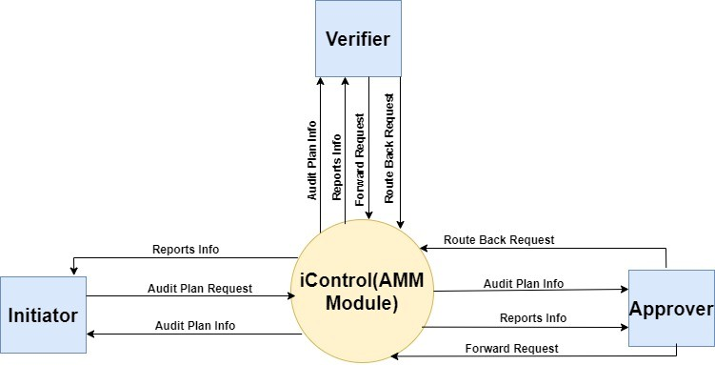

Figure 1 Level 0 DFD

Level – 1 DFD: -
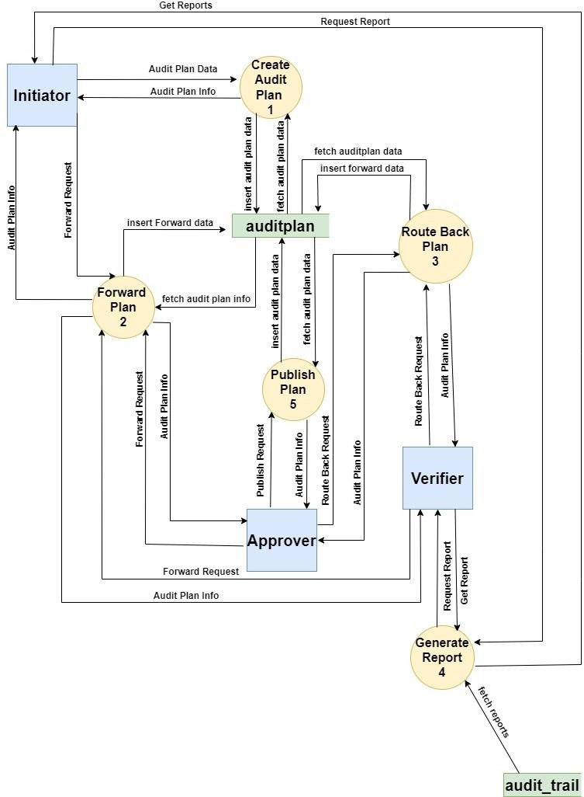

Figure 2 Level 1 DFD

Level – 2 DFD: -
      - Level 2 DFD for Process 1: -
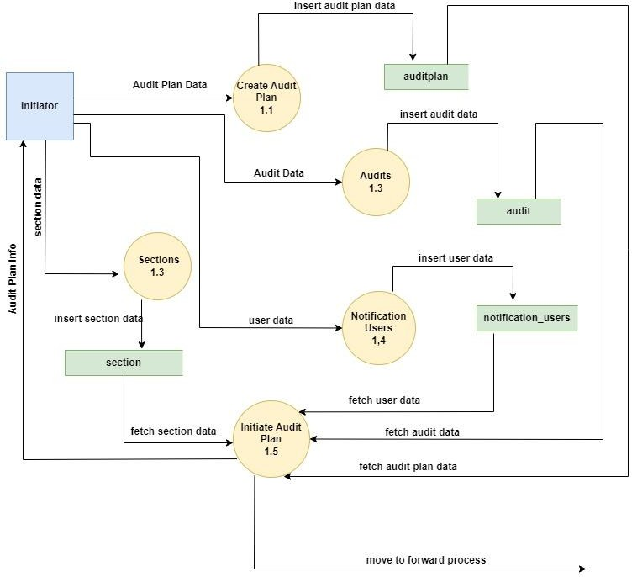

Figure 3 Level 2 DFD (Process 1)

Level 2 DFD for Process 2: -
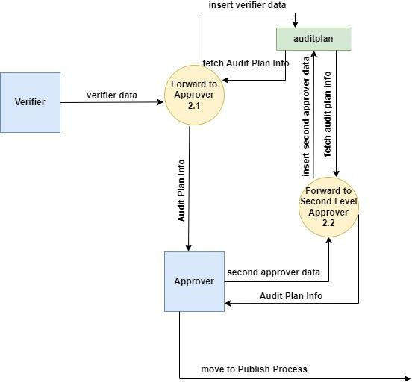

Figure 4 Level 2 DFD (Process 2)

Level 2 DFD for Process 3: -
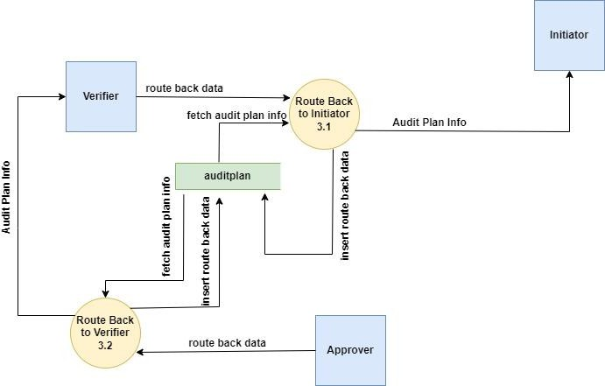

Figure 5 Level 2 DFD (Process 3)

Software Development Process
We have used iterative and incremental Waterfall Methodology in the development of iControl (AMM Module). The main reason behind using iterative waterfall model is feedback path. The Iterative Waterfall Model is a software development approach that combines the sequential steps of the traditional Waterfall Model with the flexibility of iterative design. It allows for improvements and changes to be made at each stage of the development process, instead of waiting until the end of the project. The iterative waterfall model provides feedback paths from every phase to its preceding phases, which is the main difference from the classical waterfall model.
While the incremental model approach helped us to take advantage of what was learnt during development of earlier parts of the system.
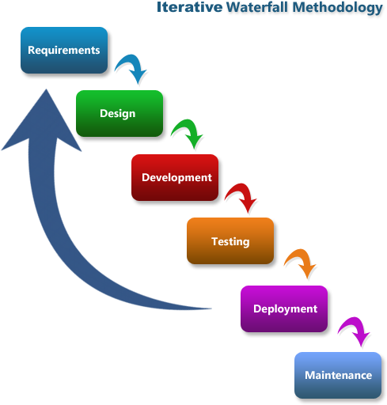

Figure 6 Software Development Process



CHAPTER 3
SYSTEM DESIGN

CHAPTER 3: SYSTEM DESIGN

System Flowchart
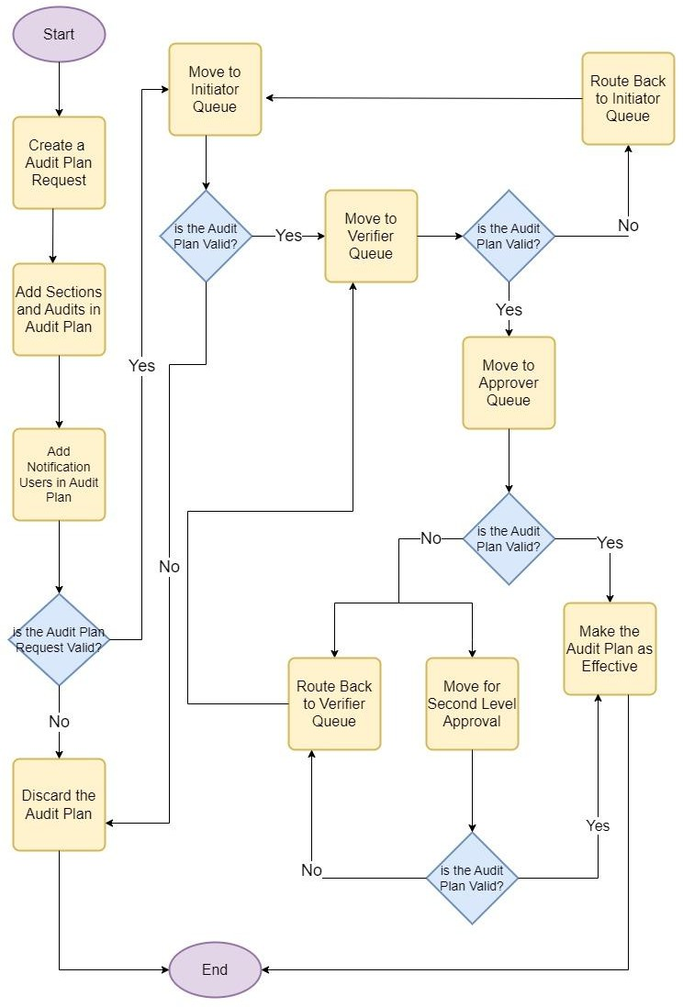

Figure 7 System Flowchart

Database Design
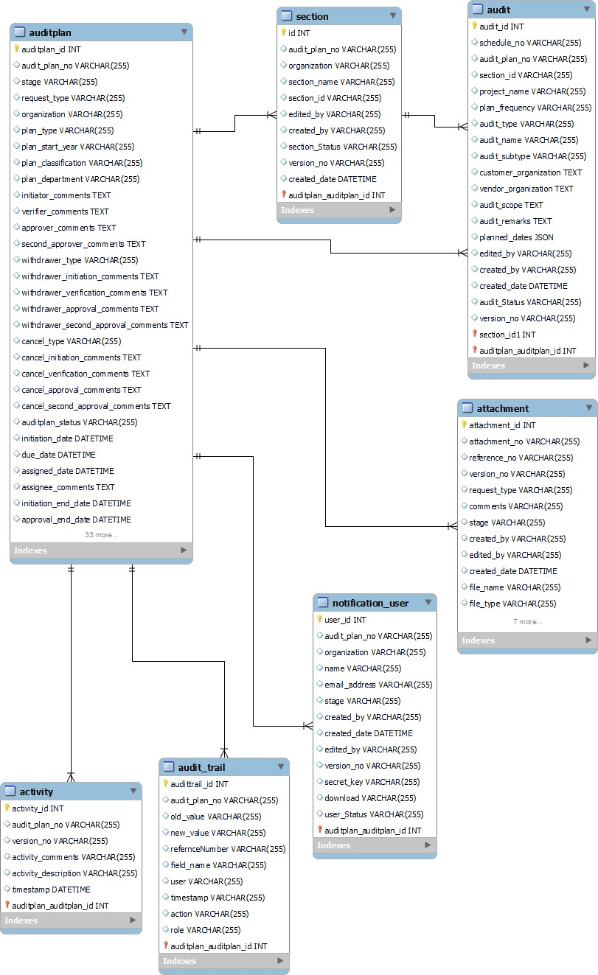

Figure 8 Database Design

Data Dictionary

auditplan Table

Field | Type | Null | Key | Default | Extra
auditplan_id | int | NO | PRIMARY | NULL | auto_increment
audit_plan_no | varchar(255) | YES |  | NULL
version_no | varchar(255) | YES |  | NULL
request_type | varchar(255) | YES |  | NULL
organization | varchar(255) | YES |  | NULL
plan_type | varchar(255) | YES |  | NULL
plan_start_year | varchar(255) | YES |  | NULL
plan_classification | varchar(255) | YES |  | NULL
plan_department | varchar(255) | YES |  | NULL
initiator_comments | text | YES |  | NULL
verifier_comments | text | YES |  | NULL
approver_comments | text | YES |  | NULL
second_approver_comments | text | YES |  | NULL
withdrawer_type | varchar(255) | YES |  | NULL
withdrawer_initiation_comments | text | YES |  | NULL
withdrawer_verification_comments | text | YES |  | NULL
withdrawer_approval_comments | text | YES |  | NULL
withdrawer_second_approval_comments | text | YES |  | NULL
cancel_type | varchar(255) | YES |  | NULL
cancel_initiation_comments | text | YES |  | NULL
cancel_verification_comments | text | YES |  | NULL
cancel_approval_comments | text | YES |  | NULL
cancel_second_approval_comments | text | YES |  | NULL
auditplan_status | varchar(255) | YES |  | NULL
initiation_date | datetime | YES |  | NULL
due_date | datetime | YES |  | NULL
assigned_date | datetime | YES |  | NULL
assignee_comments | text | YES |  | NULL
initiation_end_date | datetime | YES |  | NULL
approval_end_date | datetime | YES |  | NULL
second_approval_end_date | datetime | YES |  | NULL
verification_end_date | datetime | YES |  | NULL
initiator_name | varchar(255) | YES |  | NULL
initiator_designation | varchar(255) | YES |  | NULL
initiator_signature | varchar(255) | YES |  | NULL
verifier_name | varchar(255) | YES |  | NULL
verifier_designation | varchar(255) | YES |  | NULL
verifier_signature | varchar(255) | YES |  | NULL
approver_name | varchar(255) | YES |  | NULL
approver_designation | varchar(255) | YES |  | NULL
approver_signature | varchar(255) | YES |  | NULL
second_approver_name | varchar(255) | YES |  | NULL

second_approver_designation | varchar(255) | YES |  | NULL
second_approver_signature | varchar(255) | YES |  | NULL
initiator_assignee | varchar(255) | YES |  | NULL
verifier_assignee | varchar(255) | YES |  | NULL
approver_assignee | varchar(255) | YES |  | NULL
second_approver_assignee | varchar(255) | YES |  | NULL
assigned_by | varchar(255) | YES |  | NULL
current_handler | varchar(255) | YES |  | NULL
routed_comments | varchar(255) | YES |  | NULL
routed_title | varchar(255) | YES |  | NULL
routed_date | datetime | YES |  | NULL
stage | varchar(255) | YES |  | NULL
sequence_no | varchar(255) | YES |  | NULL
routed_status | varchar(255) | YES |  | FALSE
second_approver_Status | varchar(255) | YES |  | FALSE
revise_Status | varchar(255) | YES |  | FALSE
withdraw_Status | varchar(255) | YES |  | FALSE
draft_Status | varchar(255) | YES |  | FALSE
created_by | varchar(255) | YES |  | NULL
created_date | datetime | YES |  | NULL
edited_by | varchar(255) | YES |  | NULL

Table I auditplan Table

audit_trail Table

Field | Type | Null | Key | Default | Extra
audittrail_id | int | NO | PRIMARY | NULL | auto_increment
auditplan_id | int | NO | FOREIGN | NULL
audit_plan_no | varchar(255) | YES |  | NULL
refernceNumber | varchar(255) | YES |  | NULL
field_name | varchar(255) | YES |  | NULL
old_value | varchar(255) | YES |  | NULL
new_value | varchar(255) | YES |  | NULL
user | varchar(255) | YES |  | NULL
timestamp | varchar(255) | YES |  | NULL
action | varchar(255) | YES |  | NULL
role | varchar(255) | YES |  | NULL

Table II audit_trail Table

section Table

Field | Type | Null | Key | Default | Extra
section_id | int | NO | PRIMARY | NULL | auto_increment
auditplan_id | int | NO | FOREIGN | NULL
audit_plan_no | varchar(255) | YES |  | NULL
version_no | varchar(255) | YES |  | NULL
section_name | varchar(255) | YES |  | NULL
section_no | varchar(255) | YES |  | NULL
edited_by | varchar(255) | YES |  | NULL
created_by | varchar(255) | YES |  | NULL
organization | varchar(255) | YES |  | NULL
created_date | datetime | YES |  | NULL
section_Status | varchar(255) | YES |  | NULL

Table III section Table

audit Table

Field | Type | Null | Key | Default | Extra
audit_id | int | NO | PRIMARY | NULL | auto_increment
auditplan_id | int | NO | FOREIGN | NULL
section_id | int | NO | FOREIGN | NULL
audit_plan_no | varchar(255) | YES |  | NULL
section_no | varchar(255) | YES |  | NULL
version_no | varchar(255) | YES |  | NULL
schedule_no | varchar(255) | YES |  | NULL
project_name | varchar(255) | YES |  | NULL
plan_frequency | varchar(255) | YES |  | NULL
audit_type | varchar(255) | YES |  | NULL
audit_name | varchar(255) | YES |  | NULL
audit_subtype | varchar(255) | YES |  | NULL
customer_organization | text | YES |  | NULL
vendor_organization | text | YES |  | NULL
audit_scope | text | YES |  | NULL
audit_remarks | text | YES |  | NULL
planned_dates | json | YES |  | NULL
edited_by | varchar(255) | YES |  | NULL
created_by | varchar(255) | YES |  | NULL
created_date | datetime | YES |  | NULL
audit_Status | varchar(255) | YES |  | NULL

Table IV audit Table

attachment Table

Field | Type | Null | Key | Default | Extra
attachment_id | int | NO | PRIMARY | NULL | auto_increment
auditplan_id | int | NO | FOREIGN | NULL
audit_plan no | varchar(255) | YES |  | NULL
version_no | varchar(255) | YES |  | NULL
attachment_no | varchar(255) | YES |  | NULL
request_type | varchar(255) | YES |  | NULL
comments | varchar(255) | YES |  | NULL
stage | varchar(255) | YES |  | NULL
created_by | varchar(255) | YES |  | NULL
file_name | varchar(255) | YES |  | NULL
file_type | varchar(255) | YES |  | NULL
file_size | varchar(255) | YES |  | NULL
file_category | varchar(255) | YES |  | NULL
file_classification | varchar(255) | YES |  | NULL
s3_filename | varchar(255) | YES |  | NULL
s3_url | varchar(255) | YES |  | NULL
attachment_Status | varchar(255) | YES |  | NULL
edited_by | varchar(255) | YES |  | NULL
created_date | datetime | YES |  | NULL

Table V attachment Table

notification_users Table

Field | Type | Null | Key | Default | Extra
user_id | int | NO | PRIMARY | NULL | auto_increment
auditplan_id | int | NO | FOREIGN | NULL
audit_plan_no | varchar(255) | YES |  | NULL
version_no | varchar(255) | YES |  | NULL
organization | varchar(255) | YES |  | NULL
name | varchar(255) | YES |  | NULL
email_address | varchar(255) | YES |  | NULL
stage | varchar(255) | YES |  | NULL
created_by | varchar(255) | YES |  | NULL
created_date | datetime | YES |  | NULL
edited_by | varchar(255) | YES |  | NULL
secret_key | varchar(255) | YES |  | NULL
download | varchar(255) | YES |  | NULL
user_Status | varchar(255) | YES |  | NULL
Table VI notification_users Table

activity Table

Field | Type | Null | Key | Default | Extra
activity_id | int | NO | PRIMARY | NULL | auto_increment
auditplan_id | int | NO | FOREIGN | NULL
audit_plan_no | varchar(255) | YES |  | NULL
version_no | varchar(255) | YES |  | NULL
activity_comments | varchar(255) | YES |  | NULL
activity_description | varchar(255) | YES |  | NULL
timestamp | datetime | YES |  | NULL

Table VII activity Table

Entity-Relationship Diagram

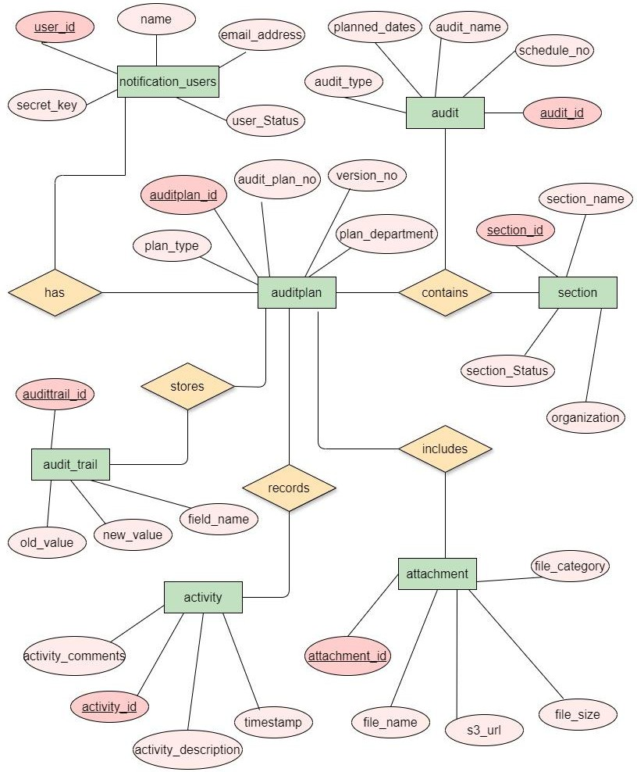

Figure 9 Entity Relationship Diagram



CHAPTER 4
TESTING

CHAPTER 4:TESTING
Software testing is an integral part of the Software Development Life Cycle (SDLC), ensuring that software meets quality standards and performs as expected. It encompasses various activities carried out at different stages of the SDLC to identify defects, improve functionality, and enhance user satisfaction. Here's how software testing is performed for Audit Management Module:

Unit Testing
Unit testing is a software testing methodology where individual units or components of a software application are tested independently to ensure their correctness and functionality. The unit testing performed on different components of AMM Module can be understood by the following table:

Test Case  ID | Test Case  Description | Test Data | Pass Condition | Fail Condition | Test  Result
TC-UT-01 | Audit Plan Creation Test | plan_type, plan_start_year, department etc. | New Audit Plan is created. | Fails to create Audit Plan. | Pass
TC-UT-02 | Section Creation Test | section_name, section_id, organization etc. | New Section is created. | Fails to create Section. | Pass
TC-UT-03 | Audit Creation Test | audit_name, audit_type, schedule_no etc. | New Audit is created. | Fails to create Audit. | Pass
TC-UT-04 | Notification User Creation Test | user_name, email_address, mobile etc. | New Notification User is created. | Fails to create Notification User. | Pass
TC-UT-05 | Recording of Audit Plan Activity | audit_plan_no, section_no, schedule_no,  user_id etc. | Successfully recorded and saved activity in database | Fails to record activity. | Pass
TC-UT-06 | Email Notification Test | audit_plan_no, user_id, version_no | Email Notification sent to users | Fails to send email to  intended users. | Pass

Test Case ID | Test Case Description | Test Data | Pass Condition | Fail Condition | Test Result
TC-UT-07 | Draft Creation Test | organization, plan_type, plan_start_year etc. | Draft Created Successfully | Unable to Create Draft | Pass
TC-UT-08 | Audit Plan Revise Request Initiation Test | request_type, audit_plan_no, version_no, section_name,  audit_name etc. | Revise Request initiated successfully. | Request is not initiated, error occurred. | Pass
TC-UT-09 | Audit Plan Withdraw Request Initiation Test | request_type, audit_plan_no, version_no, section_name,  audit_name etc. | Withdraw Request initiated successfully. | Request is not initiated, error occurred. | Pass
TC-UT-10 | Audit Plan Cancel Request Initiation Test | request_type, audit_plan_no, version_no, section_name,  audit_name etc. | Cancel Request initiated successfully. | Request is not initiated, error occurred. | Pass
TC-UT-11 | Update Request for  Audit Plan, Section, Audit  and User | audit_plan_no, version_no, section_id, schedule_no,  user_id etc. | Updated Successfully | Unable to update Audit Plan, Section, Audit, notification_user | Pass
TC-UT-12 | Delete Request for Audit Plan, Section, Audit and User | audit_plan_no, version_no, section_id, schedule_no,  user_id etc. | Deleted Successfully | Unable to delete Audit Plan, Section, Audit, notification_user | Pass

Table VIII Unit Testing

Integration Testing
Integration Testing is a software testing methodology that focusses on verifying the interaction between different modules of a software system when they are integrated together. The main goal of integration testing is to detect any inconsistencies, interface issues or defects that may arise due to interaction between these modules.

Integration of AMM with iAccess Application:

Test Case ID | Test Case Scenario | Test Description | Pass Condition | Fail Condition | Test Result
TC-INT-01 | JWT Token Generation | Verify successful generation of JWT Token upon user login to iControl  through iAccess. | A JWT Token gets generated upon user login. | No JWT Token is generated. | Pass
TC-INT-02 | JWT Token Content Check | Verify that JWT Token contains necessary user  identity and  permissions | Token contains user identity, roles and access rights. | Missing or False information is present in token | Pass
TC-INT-03 | Role Selection | Test the  functionality of selecting role within iAccess for AMM Module | User is able to select role. | User encounters error during role selection. | Pass
TC-INT-04 | Role Permission Check | Ensure that selected role corresponds to user permission and  access rights | Selected role grants appropriate permission and  access rights. | Does not grant required permissions. | Pass
TC-INT-05 | Automatic Login | Test the automatic login process from iAccess to iControl  after role selection. | User is seamlessly logged in. | User encounters error while log in. | Pass
Table IX Integration Testing with iAccess

Integration of AMM with CAPA and Vendor Management Module:

Test Case ID | Test Case Scenario | Test Description | Pass Condition | Fail Condition | Test Result
TC-INT-06 | Data Integration | Verify that data is correctly synchronized between AMM,  CAPA and VMM | Accurately Synchronized. | Discrepancies found in data. | Pass
TC-INT-07 | Interface Integration | Test interface to ensure consistency in design elements. | Consistent Design. | Inconsistencies observed. | Pass
Table X Integration Testing with CAPA and VMM

System Testing
System Testing is a comprehensive software testing phase where the entire integrated system is tested as a whole to validate its behaviour and functionality against specifies requirements.
    - Functional Testing: Functional Testing involves validating that each function of software application operates as expected, adhering to defined requirements and specification.

Test Case ID | Test Case Scenario | Input / Test Data | Pass Condition | Fail Condition | Test Result
ST-FT--01 | Search Functionality | Enter specific keyword related to audit plan. | Relevant audits are displayed. | Irrelevant record or error  displayed | Pass
ST-FT-02 | Filter Functionality | Select filter options such as audit plan status or date range. | Audit Plan are filtered. | Filter option doesn’t work. | Pass
ST-FT-03 | Pagination Functionality | Pagination control allow users to navigate through multiple pages of  audit result. | Users can navigate through pagination control. | Pagination control doesn’t allow users to navigate. | Pass
ST-FT-04 | Reporting Functionality | Select Reporting Criteria. | Generated Report contains accurate and meaningful  insights. | Inaccurate or false information  present. | Pass
Table XI Function Testing

    - Non-Functional Testing: Non-Functional Testing focusses on evaluating aspects such as performance, usability, security and error handling of software ensuring it meets quality attributes beyond functional requirements.

Performance Testing:

Test Case  ID | Test Case  Scenario | Test Description | Pass Condition | Fail Condition | Test  Result
ST-NFT-01 | Response Time Testing | Measure System Response Time | Responses are generated within acceptable time  frames. | Response time exceeds threshold. | Pass
ST-NFT-02 | Load Testing | Evaluate system performance under  load | System handles unexpected load. | System crashes. | Pass

Table XII Performance Testing

Usability Testing:

Test Case ID | Test Case Scenario | Test Description | Pass Condition | Fail Condition | Test Result
ST-NFT-03 | User Interface Testing | Evaluate UI Design and Usability | User can easily navigate through system and perform task without confusion and  frustration. | UI is cluttered and confusing, leading to errors and user  dissatisfaction. | Pass

Table XIII Usability Testing

Error Handling Testing:

Test Case ID | Test Case Scenario | Test Description | Pass Condition | Fail Condition | Test Result
ST-NFT-04 | Exceptional Handling Testing | Evaluate system’s response to exceptions. | System handles the exceptions gracefully and provide meaningful  error messages. | System crashes or data loss occurs. | Pass
Table XIV Error Handling Testing

Security Testing

Test Case ID | Test Case Scenario | Test Description | Pass Condition | Fail Condition | Test Result
ST-NFT-05 | Authentication Testing | Verify User Authentication | Users are granted access only with valid credentials. | Allowing unauthorized access. | Pass
ST-NFT-06 | Authorization Testing | Test Access Controls | User can access only the resources authorized for their roles and  permissions. | Users can access unauthorized resource and perform unauthorized actions, indicating a failure in access  controls. | Pass

Table XV Security Testing



CHAPTER 5
IMPLEMENTATION

CHAPTER 5: IMPLEMENTATION
The implementation phase of the Software Development Life Cycle (SDLC) is a critical stage where the software solution is actually built and put into operation. Here are some key aspects of the implementation phase:

Integrated Development Environment (IDE) Setup
Following are some software which are being used in the development of AMM Module:

Visual Studio Code:
      - Go to the official Visual Studio website: https://visualstudio.microsoft.com/downloads/
      - Click on the "Download" button for the version of Visual Studio you want to install.
      - Choose the components you want to install, such as languages, frameworks, and tools.
      - Click on the "Install" button to start the installation process.
      - Follow the installation wizard and select the options that suit your needs.

MySQL Workbench:
      - Go to MySQL Workbench website: https://dev.mysql.com/downloads/workbench/
      - Select the appropriate version of MySQL Workbench for your operating system.
      - Click on the "Download" button to start the download.
      - Once the download is complete, run the installer.
      - Follow the installation wizard and select the options that suit your needs.

Technologies / Libraries Used
Following are libraries which are being used in the development of AMM Module:
    - React.JS: React.JS is a popular open-source JavaScript library for building user interfaces, developed by Facebook. It is widely used for creating interactive and dynamic web applications with a focus on component-based architecture and efficient rendering.
    - Node.JS: Node.js is an open-source, cross-platform JavaScript runtime environment that allows developers to run JavaScript code outside of a web browser. It is built on Chrome's V8 JavaScript engine and provides an event-driven, non-blocking I/O model that makes it lightweight and efficient for building scalable network applications.
    - Sequelize.JS: Sequelize.js is a popular Object-Relational Mapping (ORM) library for Node.js, designed to simplify database interactions by abstracting away the complexities of SQL queries and providing a JavaScript-friendly interface for interacting with relational databases.

Development Environment Setup
Following are the steps used for setting up development environment for AMM Module:

Frontend Application:
      - Create a New React App by using command "npx create-react-app my-react-app".
      - Navigate to the project directory using command "cd my-react-app".
      - Now start the development server by running the command "npm start".
      - You can access your React application in your web browser at `http://localhost:3000`.

Backend Application:
      - Go to the official Node.js website: https://nodejs.org/en/download/
      - Once Node.JS is installed, initialize node app by using "npm init".
      - Now, install dependencies as per the requirement of project.
      - You can access your Node application in your web browser at `http://localhost:4000`.

Version Control System:
      - Download and install Git from the official website: https://git-scm.com/downloads
      - Once Git is installed, you can create a new repository for your project.

Configure Environment Variables:
      - Create a .env file in the root directory of the project.
      - Add necessary environment variables such as database connection URLs and API keys.

Development Activities
Following are the activities done for the development of AMM Module
    - Coding: This involves writing algorithms, functions, classes, and other programming constructs to create the desired features and behaviour of the AMM (Audit Management Module).
    - Implementing Design Specifications: Implementing design specifications involves taking the high-level design concepts and turning them into detailed technical designs that can be translated into code. Implementing design specifications ensures that the development team has a clear understanding of the requirements and how they will be implemented in the code.
    - Code Review: During code review, developers examine the code for readability, maintainability, efficiency, and correctness. They may also provide feedback, suggestions for improvement, and identify potential issues or areas of concern. Code review helps maintain code quality, fosters knowledge sharing among team members, and reduces the likelihood of introducing defects into the codebase.

Deployment
In the Software Development Life Cycle (SDLC), deployment is the phase where the developed software is released and made available for use by end-users or customers. AMM Module is deployed using the AWS Clous Services.

Deployment Architecture:
      - A database is deployed and served using AWS managed database service (AWS RDS).
      - The backend is deployed on a server with public IP using AWS EC2 Server.
      - The frontend application is deployed and served on AWS S3.
      - All the application components reside within an AWS VPC in a region.

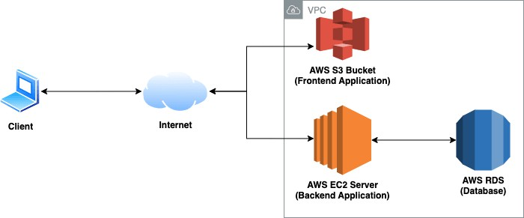

Figure 10 AWS Deployment Architecture


CHAPTER 6
SAMPLE FORM AND REPORTS

CHAPTER 6: SAMPLE FORMS AND REPORTS
  - iAccess Login Page
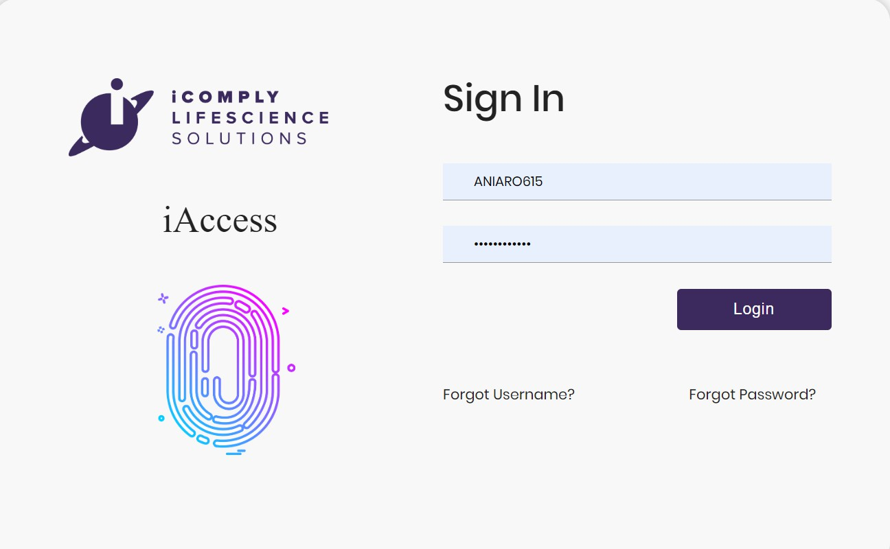
  - iControl Login Page
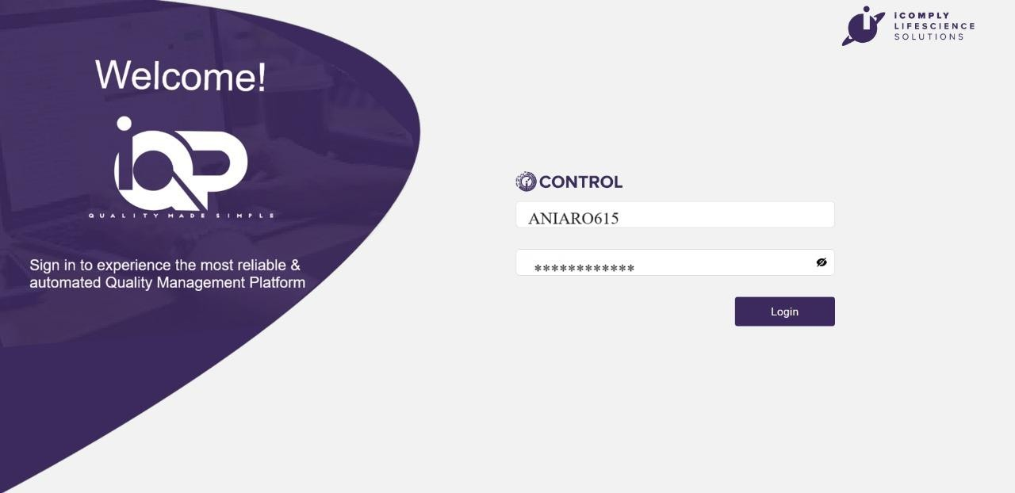

  - Notification User Login Form
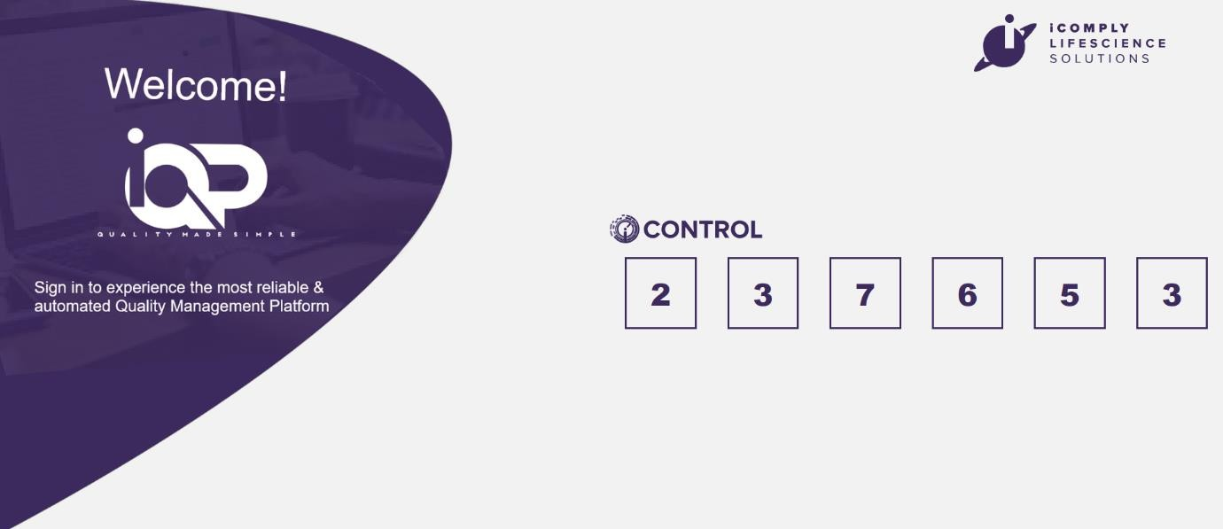
  - Audit Plan Initiation Form
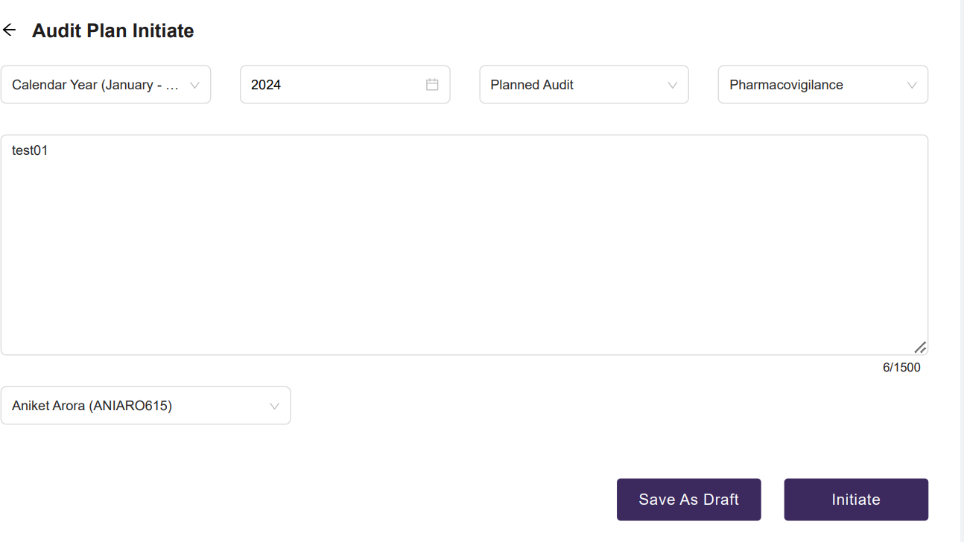
  - Draft List Table
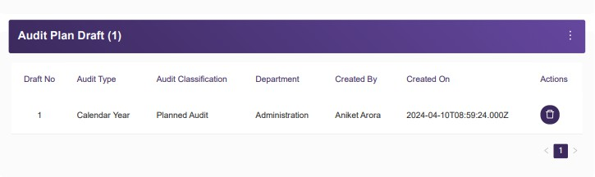

  - Audit Plan Revise Form
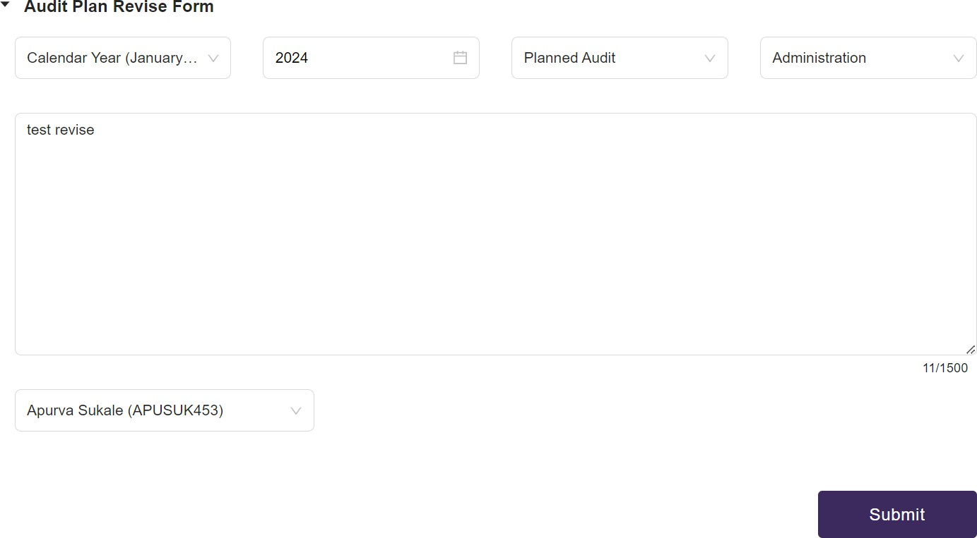

  - Audit Plan Withdrawal Form
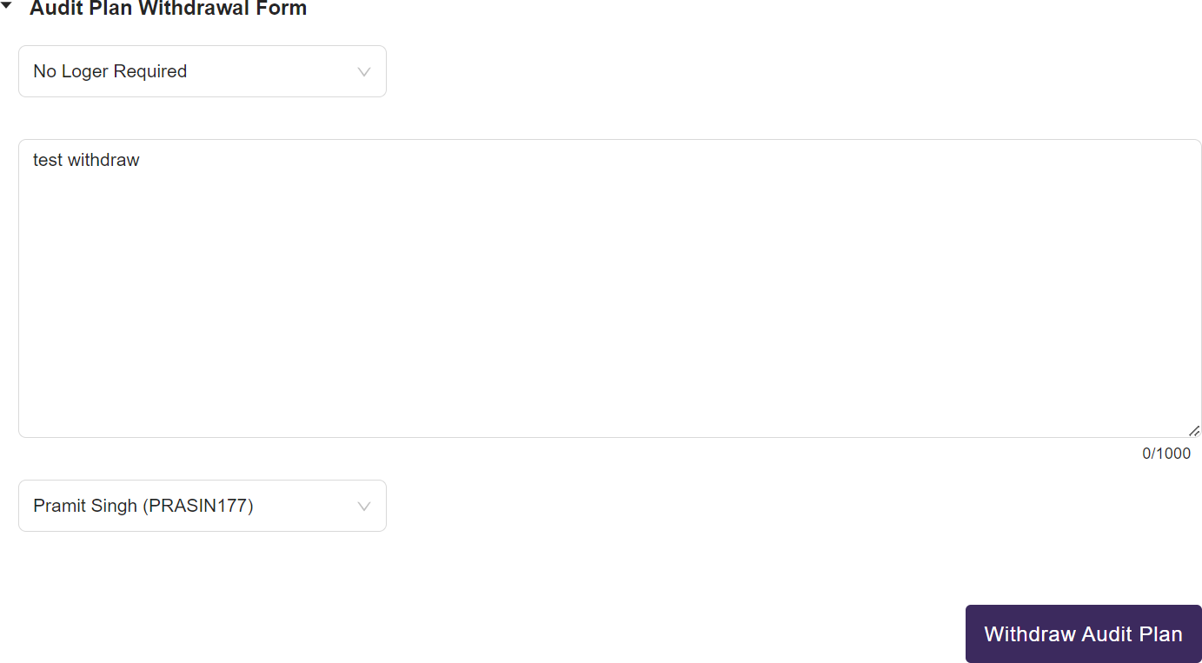

  - Audit Plan Cancel Form
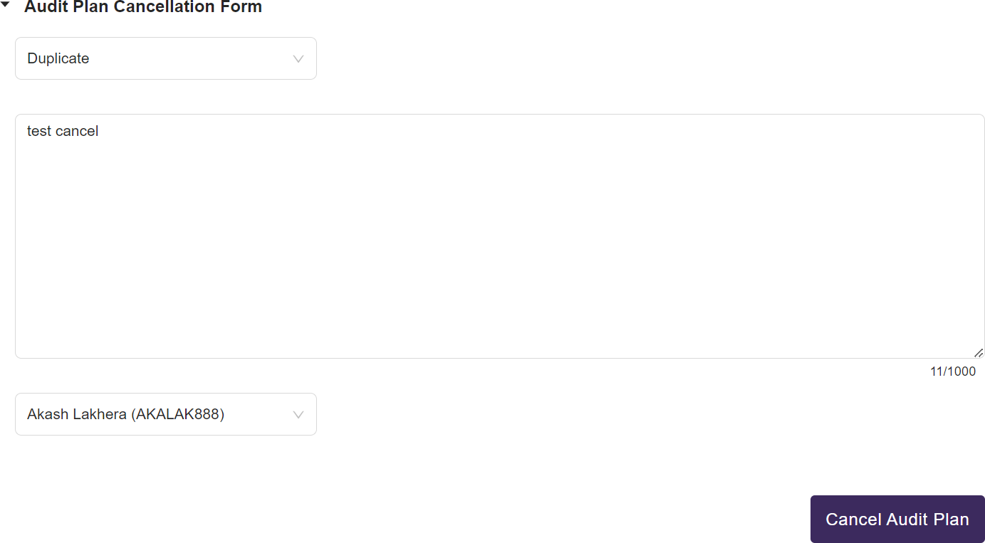
  - Audit Plan Forward Form
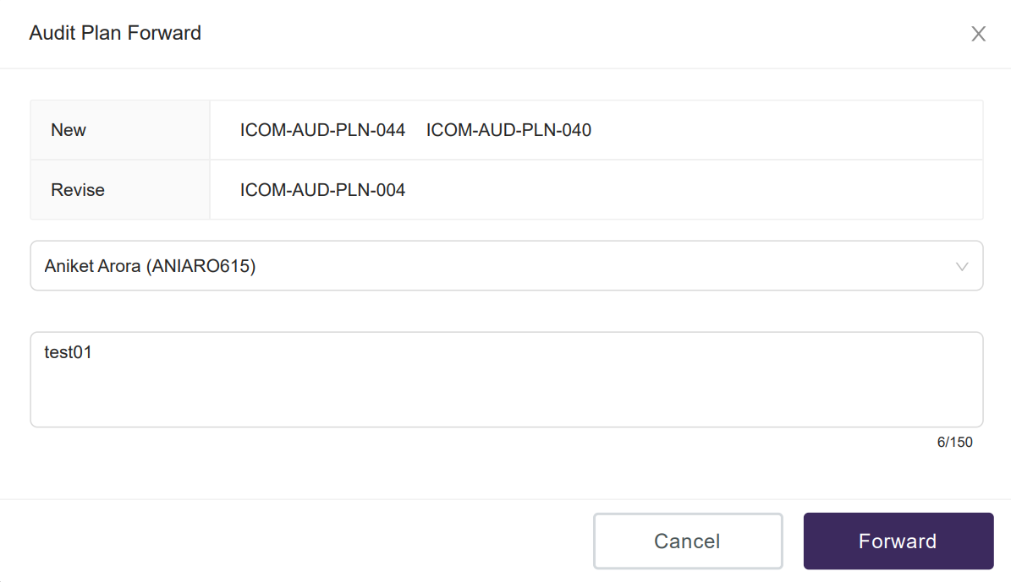

  - Audit Plan Change Assignee Form
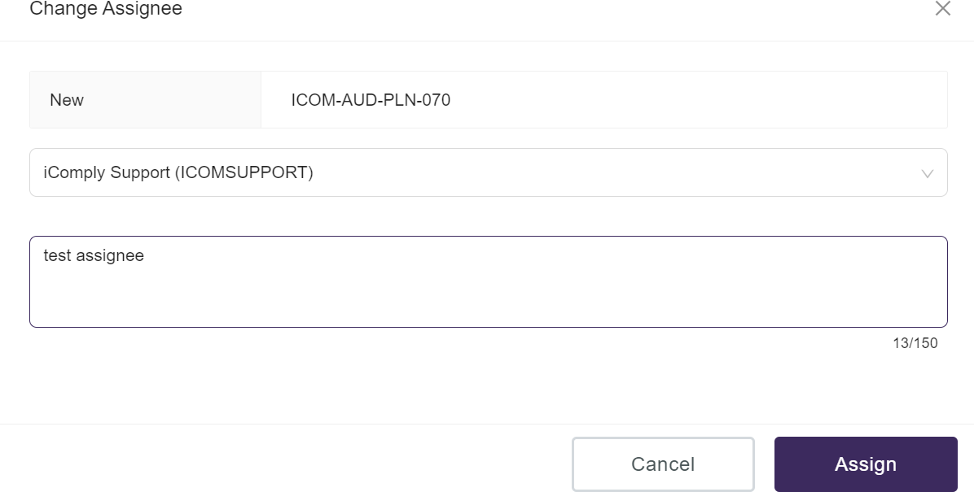
  - Electronic Signature Card
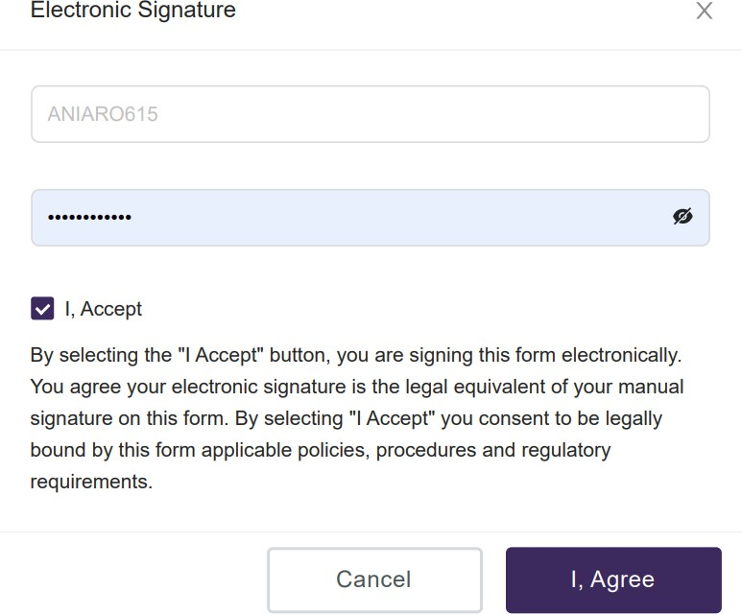

  - Switch Role Card
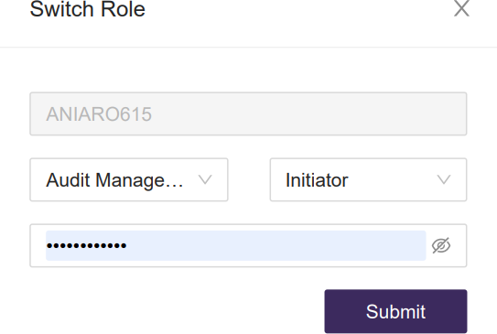

  - Audit Form
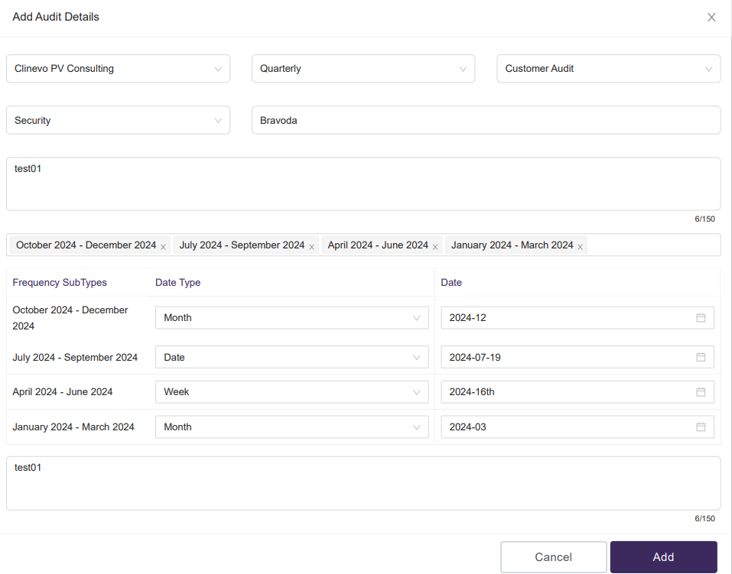

  - Filter Data Form
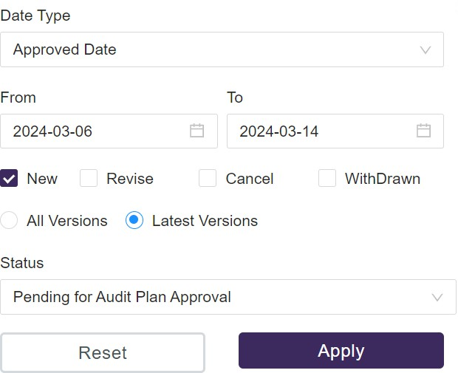

  - Dashboard
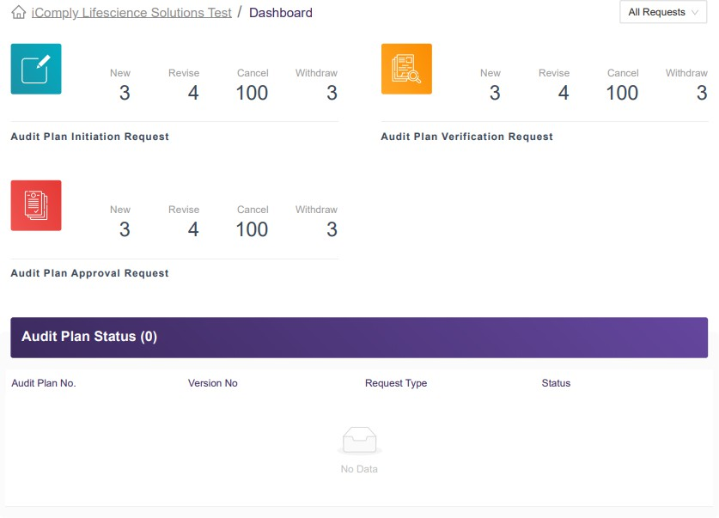

  - Audit Plan Pending Worklist Table
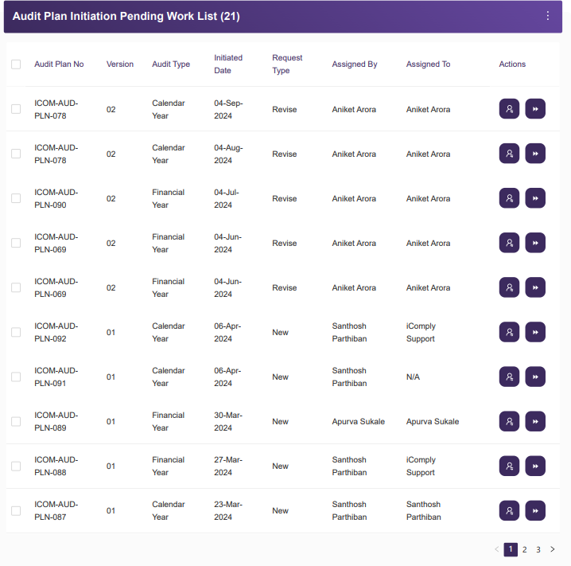

  - Audit Plan Chart
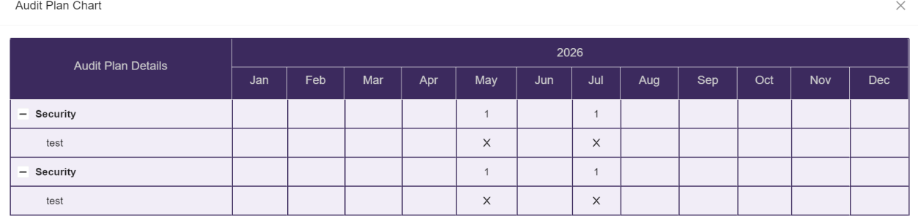

  - Notification User Email
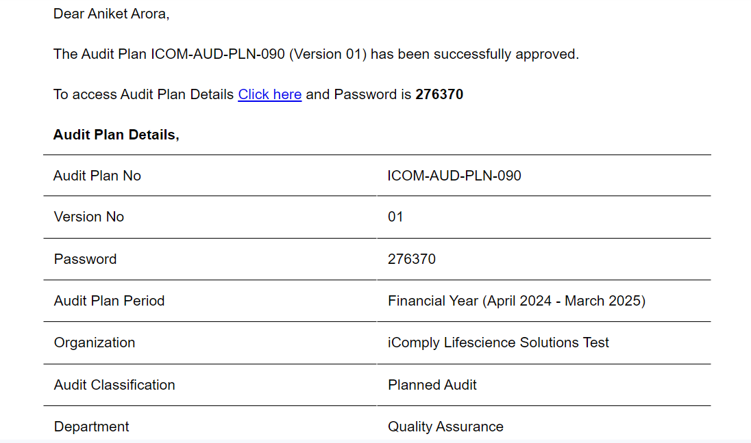

  - Activity Modal
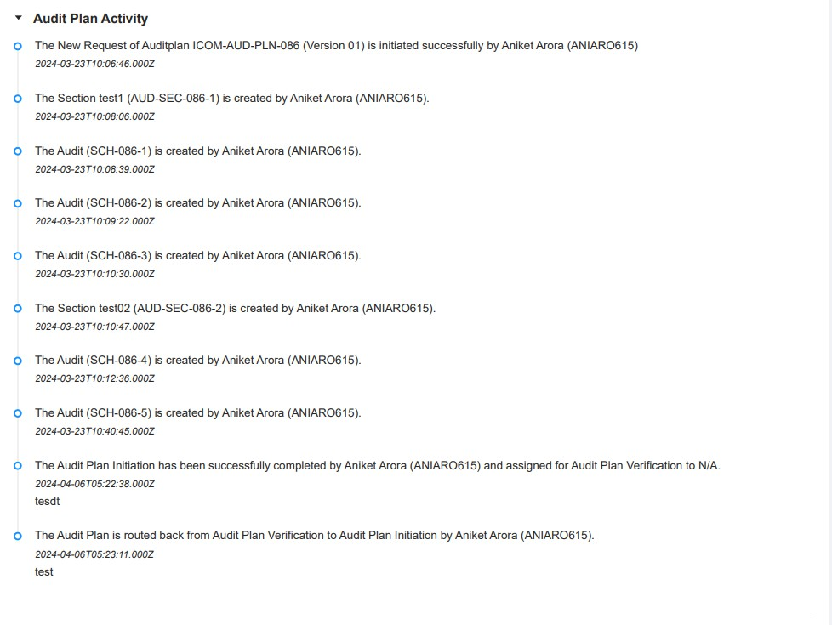

  - View Audit Modal
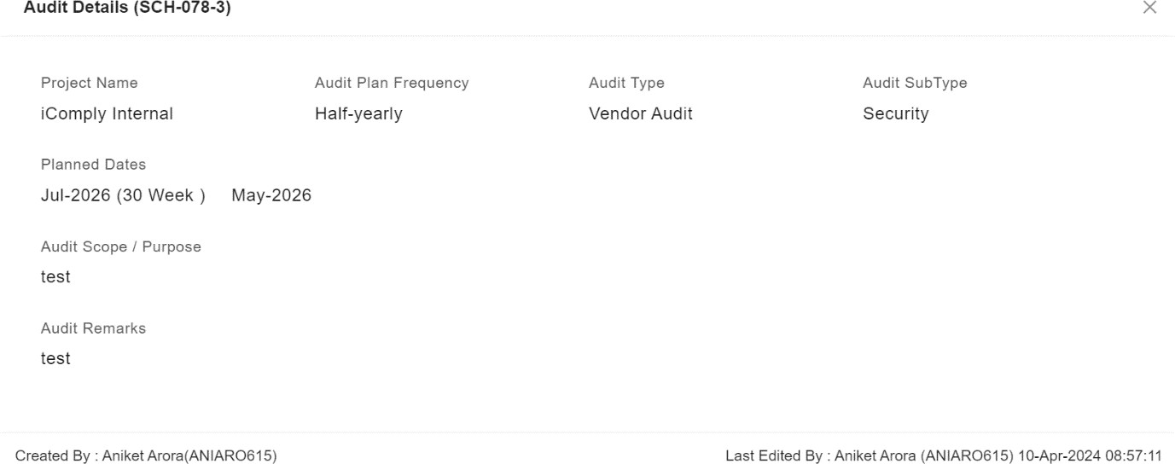

  - Report and Logs Dashboard
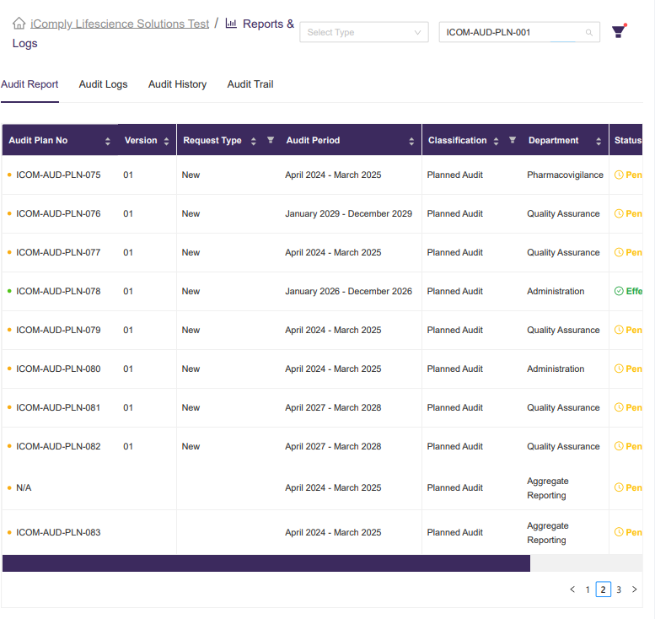



CHAPTER 7
CONCLUSION

CHAPTER 7: CONCLUSION
In conclusion, the Audit Management Module emerges as a pivotal solution addressing the intricate challenges encountered in auditing processes across various industries. By streamlining and enhancing the audit workflow, this module not only empowers auditors but also augments organizational efficiency and compliance standards.

Through its intuitive interface, seamless integration with existing systems, and robust audit trail mechanisms, the Audit Management Module offers a gateway for organizations to manage audits with precision and confidence. By facilitating secure data handling, real-time monitoring, and comprehensive reporting capabilities, it elevates audit quality and transparency.

The project’s economic viability, as demonstrated through meticulous cost-benefit analyses and resource allocation strategies, underscores its practicality and return on investment. Leveraging advanced technologies and methodologies, the technical feasibility of the Audit Management Module is assured, providing a seamless experience for auditors and stakeholders alike. Moreover, the module’s behavioral feasibility is evident in its user-centric design, emphasizing user-friendliness, accessibility, and ongoing training support.

Beyond its technical and economic merits, the Audit Management Module contributes to positive organizational and societal impacts. It fosters a culture of compliance, risk mitigation, and continuous improvement within organizations. By promoting accountability, transparency, and best practices, the module serves as a catalyst for organizational resilience, growth, and trust.

In essence, the Audit Management Module transcends its role as a mere tool; it is a catalyst for organizational excellence, a guardian of integrity, and a promoter of good governance. By embracing innovation and efficiency, this initiative lays the foundation for a future where audits are not just routine procedures, but strategic enablers of success. Through the Audit Management Module, organizations embark on a journey towards enhanced performance, credibility, and sustainable growth.

Bibliography
The following websites were referred during the analysis and execution of the AMM Module:

- https://nodejs.org/en
- https://react.dev/
- https://ant.design/
- https://formik.org/docs/guides/validation
- https://expressjs.com/
- https://docs.aws.amazon.com/
- https://jestjs.io/
- https://sequelize.org/
- https://www.npmjs.com/package/multer

Plagiarism Report
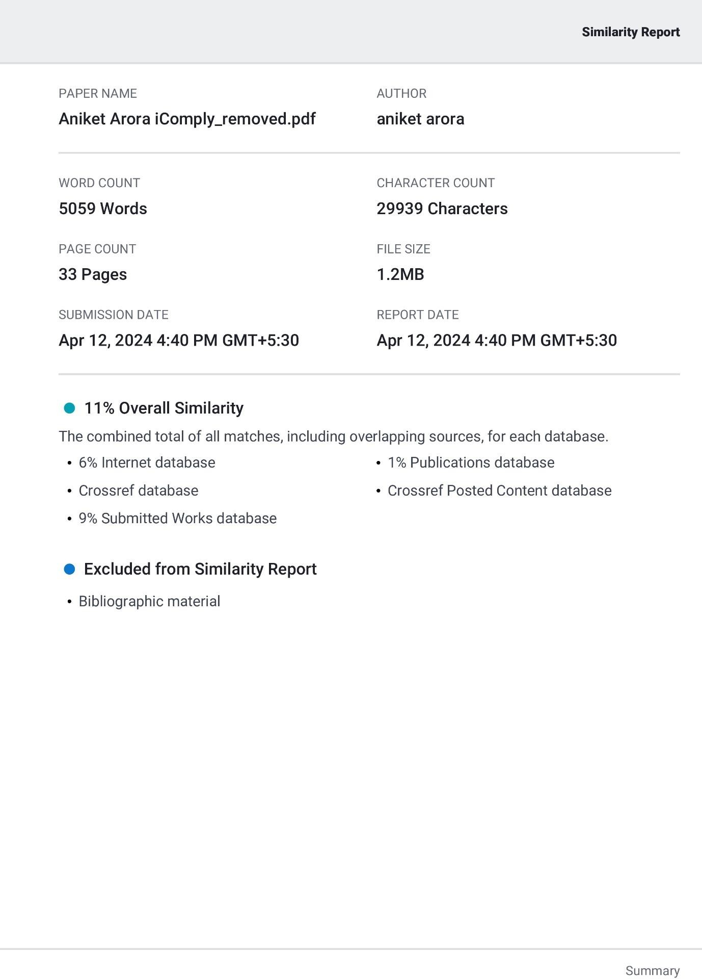

Fortnightly Progress Reports

FORTNIGHTLY PROGRESS REPORT (FPR-1) FROM INDUSTRY MENTOR

Name of Student | ANIKET ARORA |  | Department | CSE (Program:MCA)
Industry/Organization | iComply Life Science Solutions Private Limited |  | Date/Duration | 01/01/2024 - 15/02/2024
Criterion | Poor | Average | Good | Very Good | Excellent
Punctuality/Timely Completion of Assigned Work |  |  |  |  | ✓
Learning Capacity/Knowledge up gradation |  |  |  | ✓
Performance/Quality of work |  |  |  |  | ✓
Behavior/Discipline/Teamwork |  |  |  |  | ✓
Sincerity/Hard work |  |  |  |  | ✓
Comment on Nature of Work Done/Area/Topic | - Design and architect backend system that meet the functional requirements.  - Write clean, efficient and maintainable code to implement the backend functionalities.
OVERALL GRADE (Anyone) | EXCELLENT
Name of Industry Mentor | Dr. Sankarlal Thillaiambalam
Signature of Industry Mentor | 

Receiving Date | 16-01-2024 | Faculty Mentor | Dr. R.S. Jadon | Sign | 


FORTNIGHTLY PROGRESS REPORT (FPR-2) FROM INDUSTRY MENTOR

Name of Student | ANIKET ARORA |  | Department | CSE (Program:MCA)
Industry/Organization | iComply Life Science Solutions Private Limited |  | Date/Duration | 16/01/2024 - 31/01/2024
Criterion | Poor | Average | Good | Very Good | Excellent
Punctuality/Timely Completion of Assigned Work |  |  |  |  | ✓
Learning Capacity/Knowledge up gradation |  |  |  |  | ✓
Performance/Quality of work |  |  |  | ✓
Behavior/Discipline/Teamwork |  |  |  |  | ✓
Sincerity/Hard work |  |  |  | ✓
Comment on Nature of Work Done/Area/Topic | - Handle user authentication, authorization, and session management.  - Design the database schema based on the application’s requirements.
OVERALL GRADE (Anyone) | EXCELLENT
Name of Industry Mentor | Dr. Sankarlal Thillaiambalam
Signature of Industry Mentor

Receiving Date | 31-01-2024 | Faculty Mentor | Dr. R.S. Jadon | Sign

FORTNIGHTLY PROGRESS REPORT (FPR-3) FROM INDUSTRY MENTOR

Name of Student | ANIKET ARORA |  | Department | CSE (Program:MCA)
Industry/Organization | iComply Life Science Solutions Private Limited |  | Date/Duration | 01/02/2024 - 15/02/2024
Criterion | Poor | Average | Good | Very Good | Excellent
Punctuality/Timely Completion of Assigned Work |  |  |  |  | ✓
Learning Capacity/Knowledge up gradation |  |  |  | ✓
Performance/Quality of work |  |  |  |  | ✓
Behavior/Discipline/Teamwork |  |  |  |  | ✓
Sincerity/Hard work |  |  |  |  | ✓
Comment on Nature of Work Done/Area/Topic | - Collaborate with designers to create visually appealing and user-friendly interfaces.  - Ensure that the application is responsive and accessible across various devices and screen sizes.
OVERALL GRADE (Anyone) | EXCELLENT
Name of Industry Mentor | Dr. Sankarlal Thillaiambalam
Signature of Industry Mentor

Receiving Date | 16-02-2024 | Faculty Mentor | Dr. R.S. Jadon | Sign

FORTNIGHTLY PROGRESS REPORT (FPR-4) FROM INDUSTRY MENTOR

Name of Student | ANIKET ARORA |  | Department | CSE (Program:MCA)
Industry/Organization | iComply Life Science Solutions Private Limited |  | Date/Duration | 16/02/2024 - 29/02/2024
Criterion | Poor | Average | Good | Very Good | Excellent
Punctuality/Timely Completion of Assigned Work |  |  |  |  | ✓
Learning Capacity/Knowledge up gradation |  |  | ✓
Performance/Quality of work |  |  |  | ✓
Behavior/Discipline/Teamwork |  |  |  |  | ✓
Sincerity/Hard work |  |  |  | ✓
Comment on Nature of Work Done/Area/Topic | - Design and maintain databases, write queries, and ensure efficient data storage and retrieval.  - Create robust APIs for communication between the front-end and back-end systems.
OVERALL GRADE (Anyone) | EXCELLENT
Name of Industry Mentor | Dr. Sankarlal Thillaiambalam
Signature of Industry Mentor

Receiving Date | 01-03-2024 | Faculty Mentor | Dr. R.S. Jadon | Sign

FORTNIGHTLY PROGRESS REPORT (FPR-5) FROM INDUSTRY MENTOR

Name of Student | ANIKET ARORA |  | Department | CSE (Program:MCA)
Industry/Organization | iComply Life Science Solutions Private Limited |  | Date/Duration | 01/03/2024 - 15/03/2024
Criterion | Poor | Average | Good | Very Good | Excellent
Punctuality/Timely Completion of Assigned Work |  |  |  |  | ✓
Learning Capacity/Knowledge up gradation |  |  |  | ✓
Performance/Quality of work |  |  |  |  | ✓
Behavior/Discipline/Teamwork |  |  |  |  | ✓
Sincerity/Hard work |  |  |  |  | ✓
Comment on Nature of Work Done/Area/Topic | - Using version control systems like Git to manage and track changes to the codebase, enabling collaboration and facilitating code review processes.
OVERALL GRADE (Anyone) | EXCELLENT
Name of Industry Mentor | Dr. Sankarlal Thillaiambalam
Signature of Industry Mentor

Receiving Date | 16-03-2024 | Faculty Mentor | Dr. R.S. Jadon | Sign

FORTNIGHTLY PROGRESS REPORT (FPR-6) FROM INDUSTRY MENTOR

Name of Student | ANIKET ARORA |  | Department | CSE (Program:MCA)
Industry/Organization | iComply Life Science Solutions Private Limited |  | Date/Duration | 16/03/2024 - 31/03/2024
Criterion | Poor | Average | Good | Very Good | Excellent
Punctuality/Timely Completion of Assigned Work |  |  |  |  | ✓
Learning Capacity/Knowledge up gradation |  |  |  |  | ✓
Performance/Quality of work |  |  |  | ✓
Behavior/Discipline/Teamwork |  |  |  |  | ✓
Sincerity/Hard work |  |  |  | ✓
Comment on Nature of Work Done/Area/Topic | - Amazon S3 Configuration for uploading images on S3 Bucket.  - Perform Unit Testing of developed Software.
OVERALL GRADE (Anyone) | EXCELLENT
Name of Industry Mentor | Dr. Sankarlal Thillaiambalam
Signature of Industry Mentor

Receiving Date | 01-04-2024 | Faculty Mentor | Dr. R.S. Jadon | Sign

FORTNIGHTLY PROGRESS REPORT (FPR-7) FROM INDUSTRY MENTOR

Name of Student | ANIKET ARORA |  | Department | CSE (Program:MCA)
Industry/Organization | iComply Life Science Solutions Private Limited |  | Date/Duration | 01/04/2024 - 15/04/2024
Criterion | Poor | Average | Good | Very Good | Excellent
Punctuality/Timely Completion of Assigned Work |  |  |  |  | ✓
Learning Capacity/Knowledge up gradation |  |  |  | ✓
Performance/Quality of work |  |  |  |  | ✓
Behavior/Discipline/Teamwork |  |  |  | ✓
Sincerity/Hard work |  |  |  |  | ✓
Comment on Nature of Work Done/Area/Topic | - Perform Integration and System Testing of the developed project.
OVERALL GRADE (Anyone) | EXCELLENT
Name of Industry Mentor | Dr. Sankarlal Thillaiambalam
Signature of Industry Mentor

Receiving Date | 16-04-2024 | Faculty Mentor | Dr. R.S. Jadon | Sign

